Jenkins CLI

To set up the Jenkins CLI (Command Line Interface), follow these steps:

1. Download the Jenkins CLI JAR file from the Jenkins server. You can do this by navigating to **http://<jenkins-server>/jnlpJars/jenkins-cli.jar** in your web browser and saving the file to your computer.

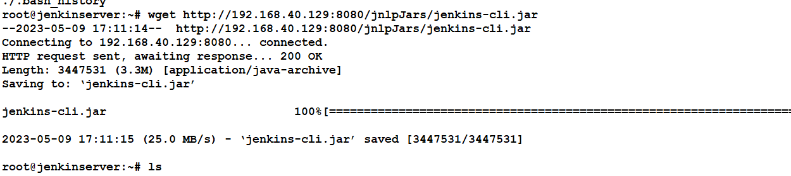

1. Install Java on your computer, if it's not already installed.
2. Open a command prompt or terminal window on your computer.
3. Navigate to the directory where you saved the Jenkins CLI JAR file.
4. Test the CLI by running the following command:

java -jar jenkins-cli.jar -s <jenkins-url> help

Replace **<jenkins-url>** with the URL of your Jenkins server. This command should display the list of available Jenkins CLI commands.

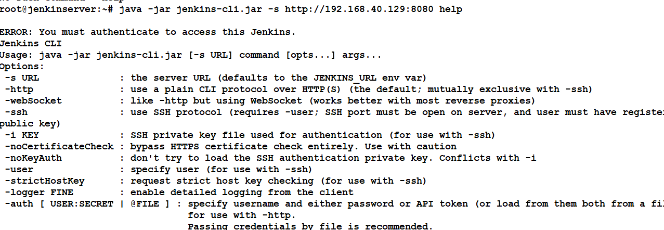

1. If the above step worked, then you can now use the Jenkins CLI to perform tasks on your Jenkins server. To run a command, use the following syntax:

java -jar jenkins-cli.jar -s <jenkins-url> <command>

java -jar jenkins-cli.jar -s http://192.168.40.129:8080 -auth admin:Welcome1 help

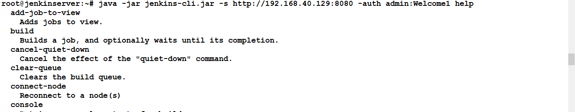

java -jar jenkins-cli.jar -s http://192.168.40.129:8080 -auth admin:Welcome1 list-jobs